Assignment 5.5
Name: keshireddy Veda Sri
Ht No: 2303A52382
Batch: 45

Task 1
Use AI to generate two solutions for checking prime
numbers:
• Naive approach(basic)
• Optimized approach
Prompt:
“Generate Python code for two prime-checking methods and
explain how the optimized version improves performance.”
Expected Output:
• Code for both methods.
• Transparent explanation of time complexity.
• Comparison highlighting efficiency improvements.
Prompt:
Generate Python code for two prime-checking methods and explain how the optimized version improves performance.

Code:
def is_prime_basic(n):
"""Check if a number is prime using basic method."""
if n <= 1:
return False
for i in range(2, n):
if n % i == 0:
return False
return True
def is_prime_optimized(n):
"""Check if a number is prime using optimized method."""
if n <= 1:
return False
if n <= 3:
return True
if n % 2 == 0 or n % 3 == 0:
return False
i = 5
while i * i <= n:
if n % i == 0 or n % (i + 2) == 0:
return False
i += 6
return True
#example:
print(is_prime_basic(29))
print(is_prime_optimized(29))
print(is_prime_basic(100))
print(is_prime_optimized(100))

Output:
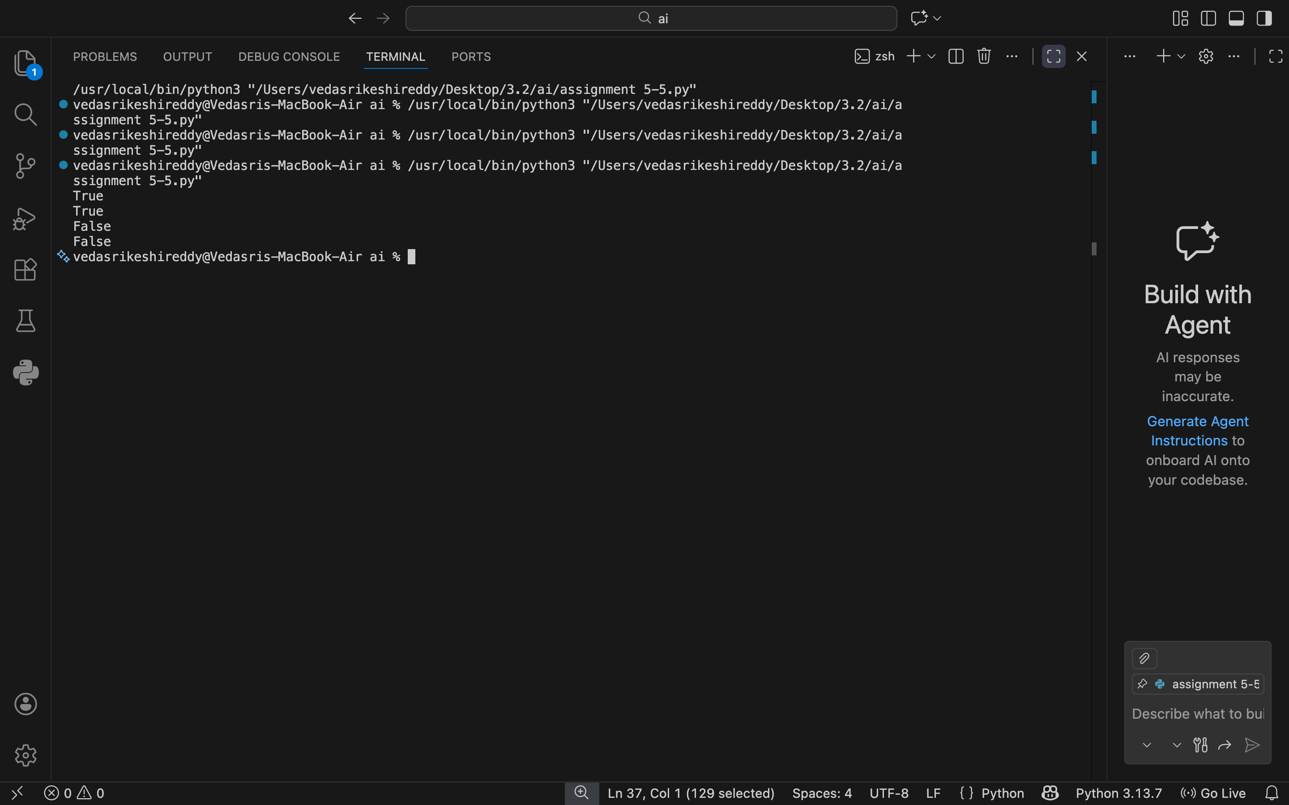

Justification:
Explanation of optimization:
The basic method checks for factors from 2 to n-1, which results in O(n) time complexity.
The optimized method reduces the number of checks significantly:
1. It eliminates even numbers and multiples of 3 right away.
2. It only checks for factors up to the square root of n, since if n is divisible by any number greater than its square root, the corresponding factor must be less than the square root.
3. It checks only numbers of the form 6k ± 1, as all primes greater than 3 can be expressed in this form.
These optimizations reduce the time complexity to O(√n), making the function much more efficient for larger numbers.

Task 2
Objective: Use AI to generate a recursive function to calculate
Fibonacci numbers.
Instructions:
1. Ask AI to add clear comments explaining recursion.
2. Ask AI to explain base cases and recursive calls.
Expected Output:
• Well-commented recursive code.
• Clear explanation of how recursion works.
• Verification that explanation matches actual execution.

Prompt:
Generate python code Use AI to generate a recursive function to calculate Fibonacci numbers. with clear comments explaining recursion and Ask AI to explain base cases and recursive calls.

Code:
def fibonacci(n):
"""Calculate the nth Fibonacci number using recursion."""
# Base case: if n is 0, return 0
if n == 0:
return 0
# Base case: if n is 1, return 1
elif n == 1:
return 1
# Recursive case: return the sum of the two preceding Fibonacci numbers
else:
return fibonacci(n - 1) + fibonacci(n - 2)
#Example
print(fibonacci(10))
print(fibonacci(5))
print(fibonacci(0))
print(fibonacci(1))

Output:
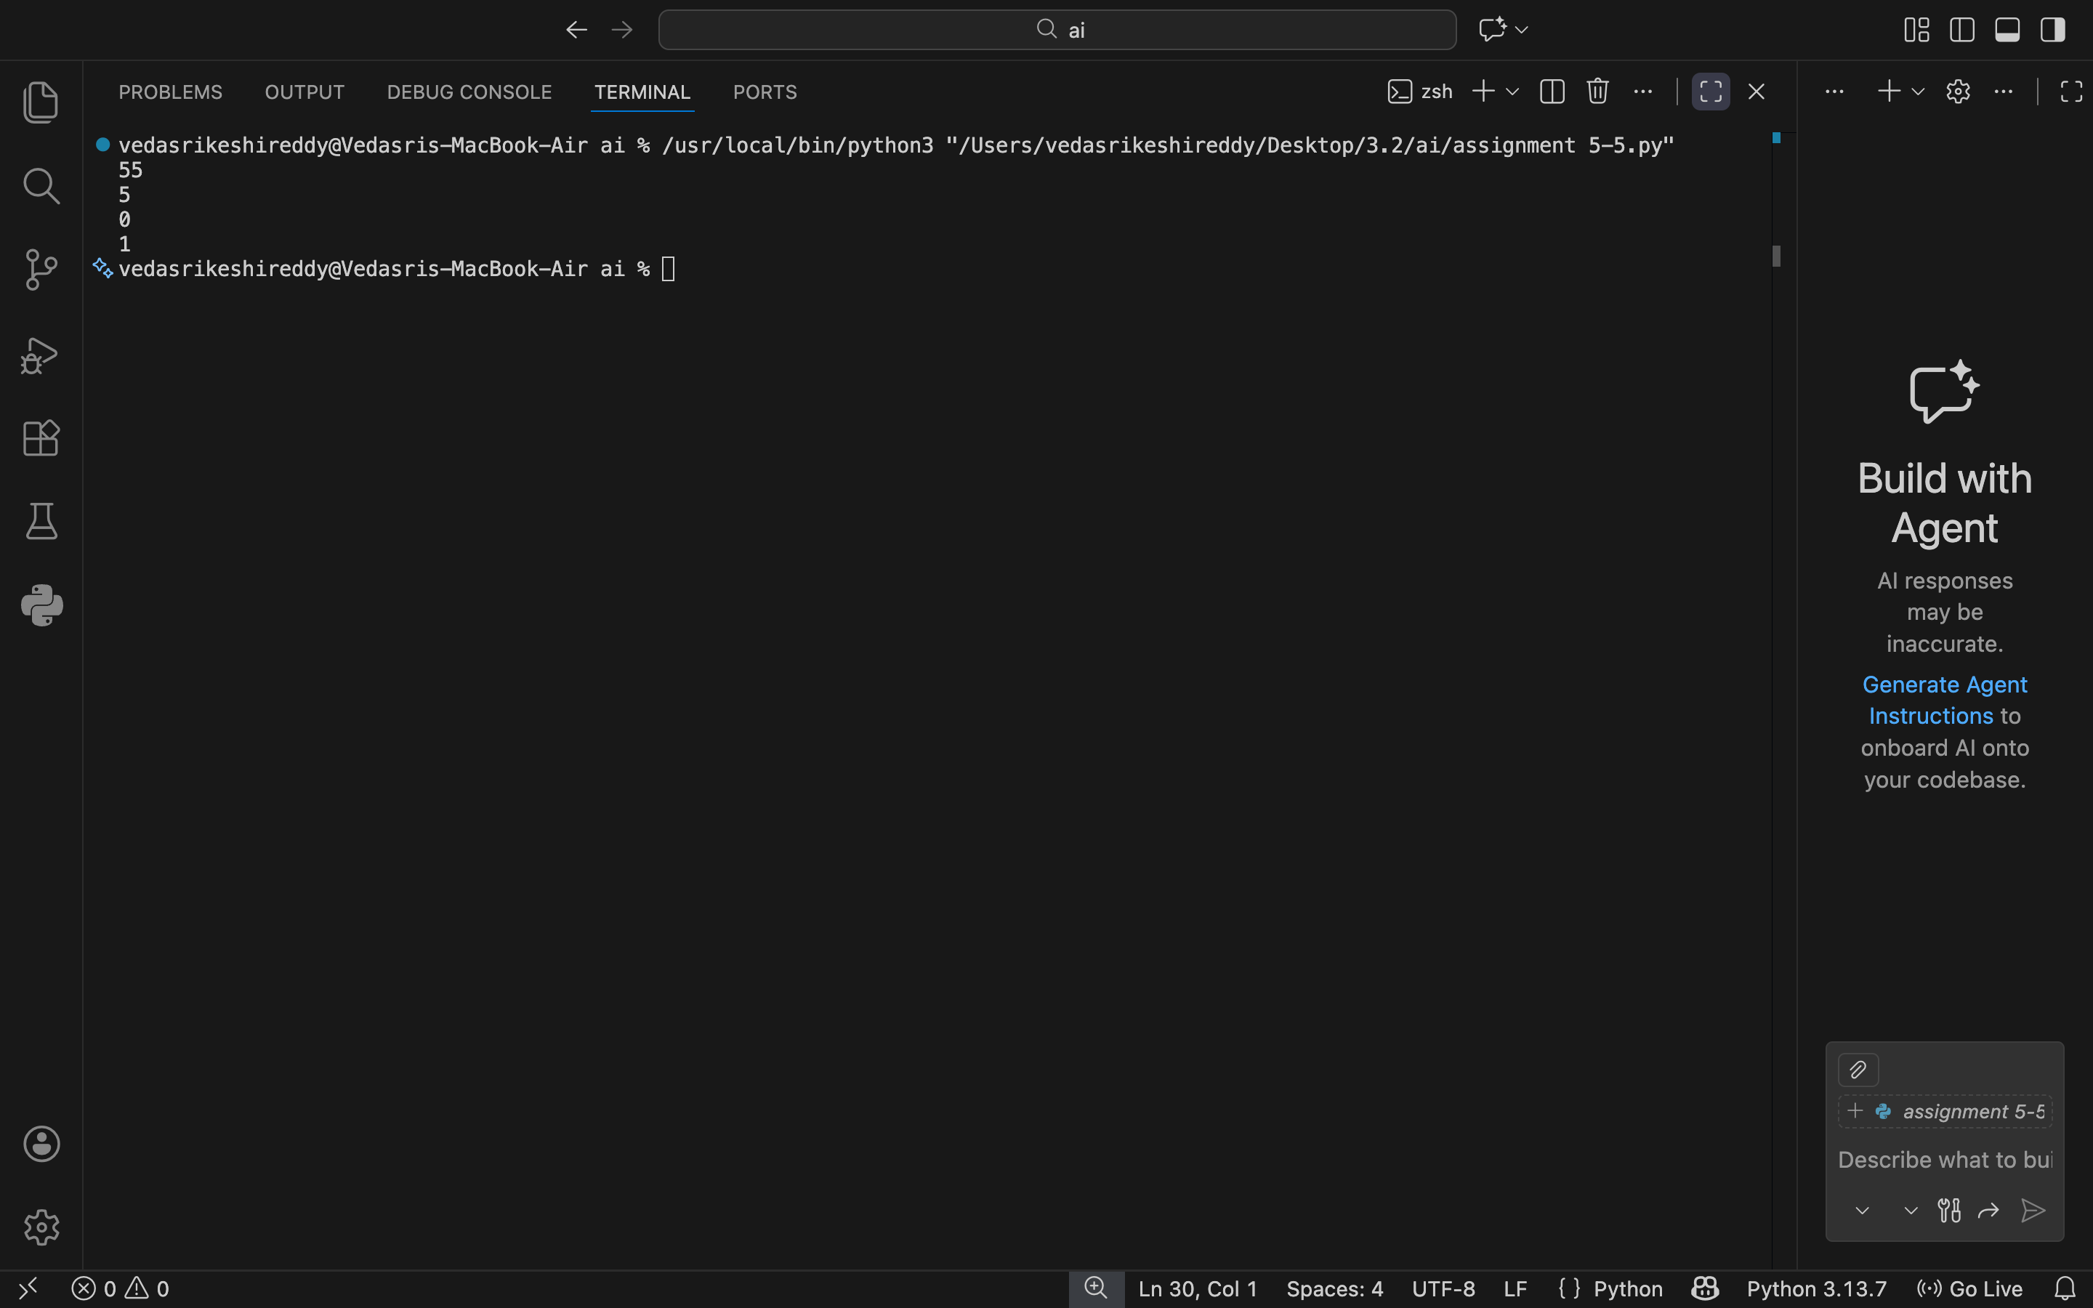

Justification:
Explanation of base cases and recursive calls:
Base Cases:
1. When n is 0, the function returns 0. This is the first number in the Fibonacci sequence.
2. When n is 1, the function returns 1. This is the second number in the Fibonacci sequence.
These base cases are essential because they provide the stopping condition for the recursion, preventing infinite loops.
Recursive Calls:
For any n greater than 1, the function calls itself twice: once with (n - 1) and once with (n - 2)
This means that to compute the nth Fibonacci number, the function needs to compute the (n-1)th and (n-2)th Fibonacci numbers first.
This process continues until the base cases are reached, at which point the function starts returning values back up the call stack, ultimately yielding the nth Fibonacci number.

Task 3
Use AI to generate a Python program that reads a file and
processes data.
Prompt:
“Generate code with proper error handling and clear explanations
for each exception.”
Expected Output:
• Code with meaningful exception handling.
• Clear comments explaining each error scenario.
• Validation that explanations align with runtime behavior.

Prompt:
Generate code with proper error handling and clear explanations for each exception.

Code:
def divide_numbers(num1, num2):
try:
result = num1 / num2
except ZeroDivisionError:
return "Error: Cannot divide by zero. Please provide a non-zero denominator."
except TypeError:
return "Error: Invalid input type. Please provide two numbers (int or float)."
else:
return result
# Example usage:
print(divide_numbers(10, 2)) # Should return 5.0
print(divide_numbers(10, 0)) # Should return error message for division by
print(divide_numbers(10, 'a')) # Should return error message for invalid input type zero

Output:
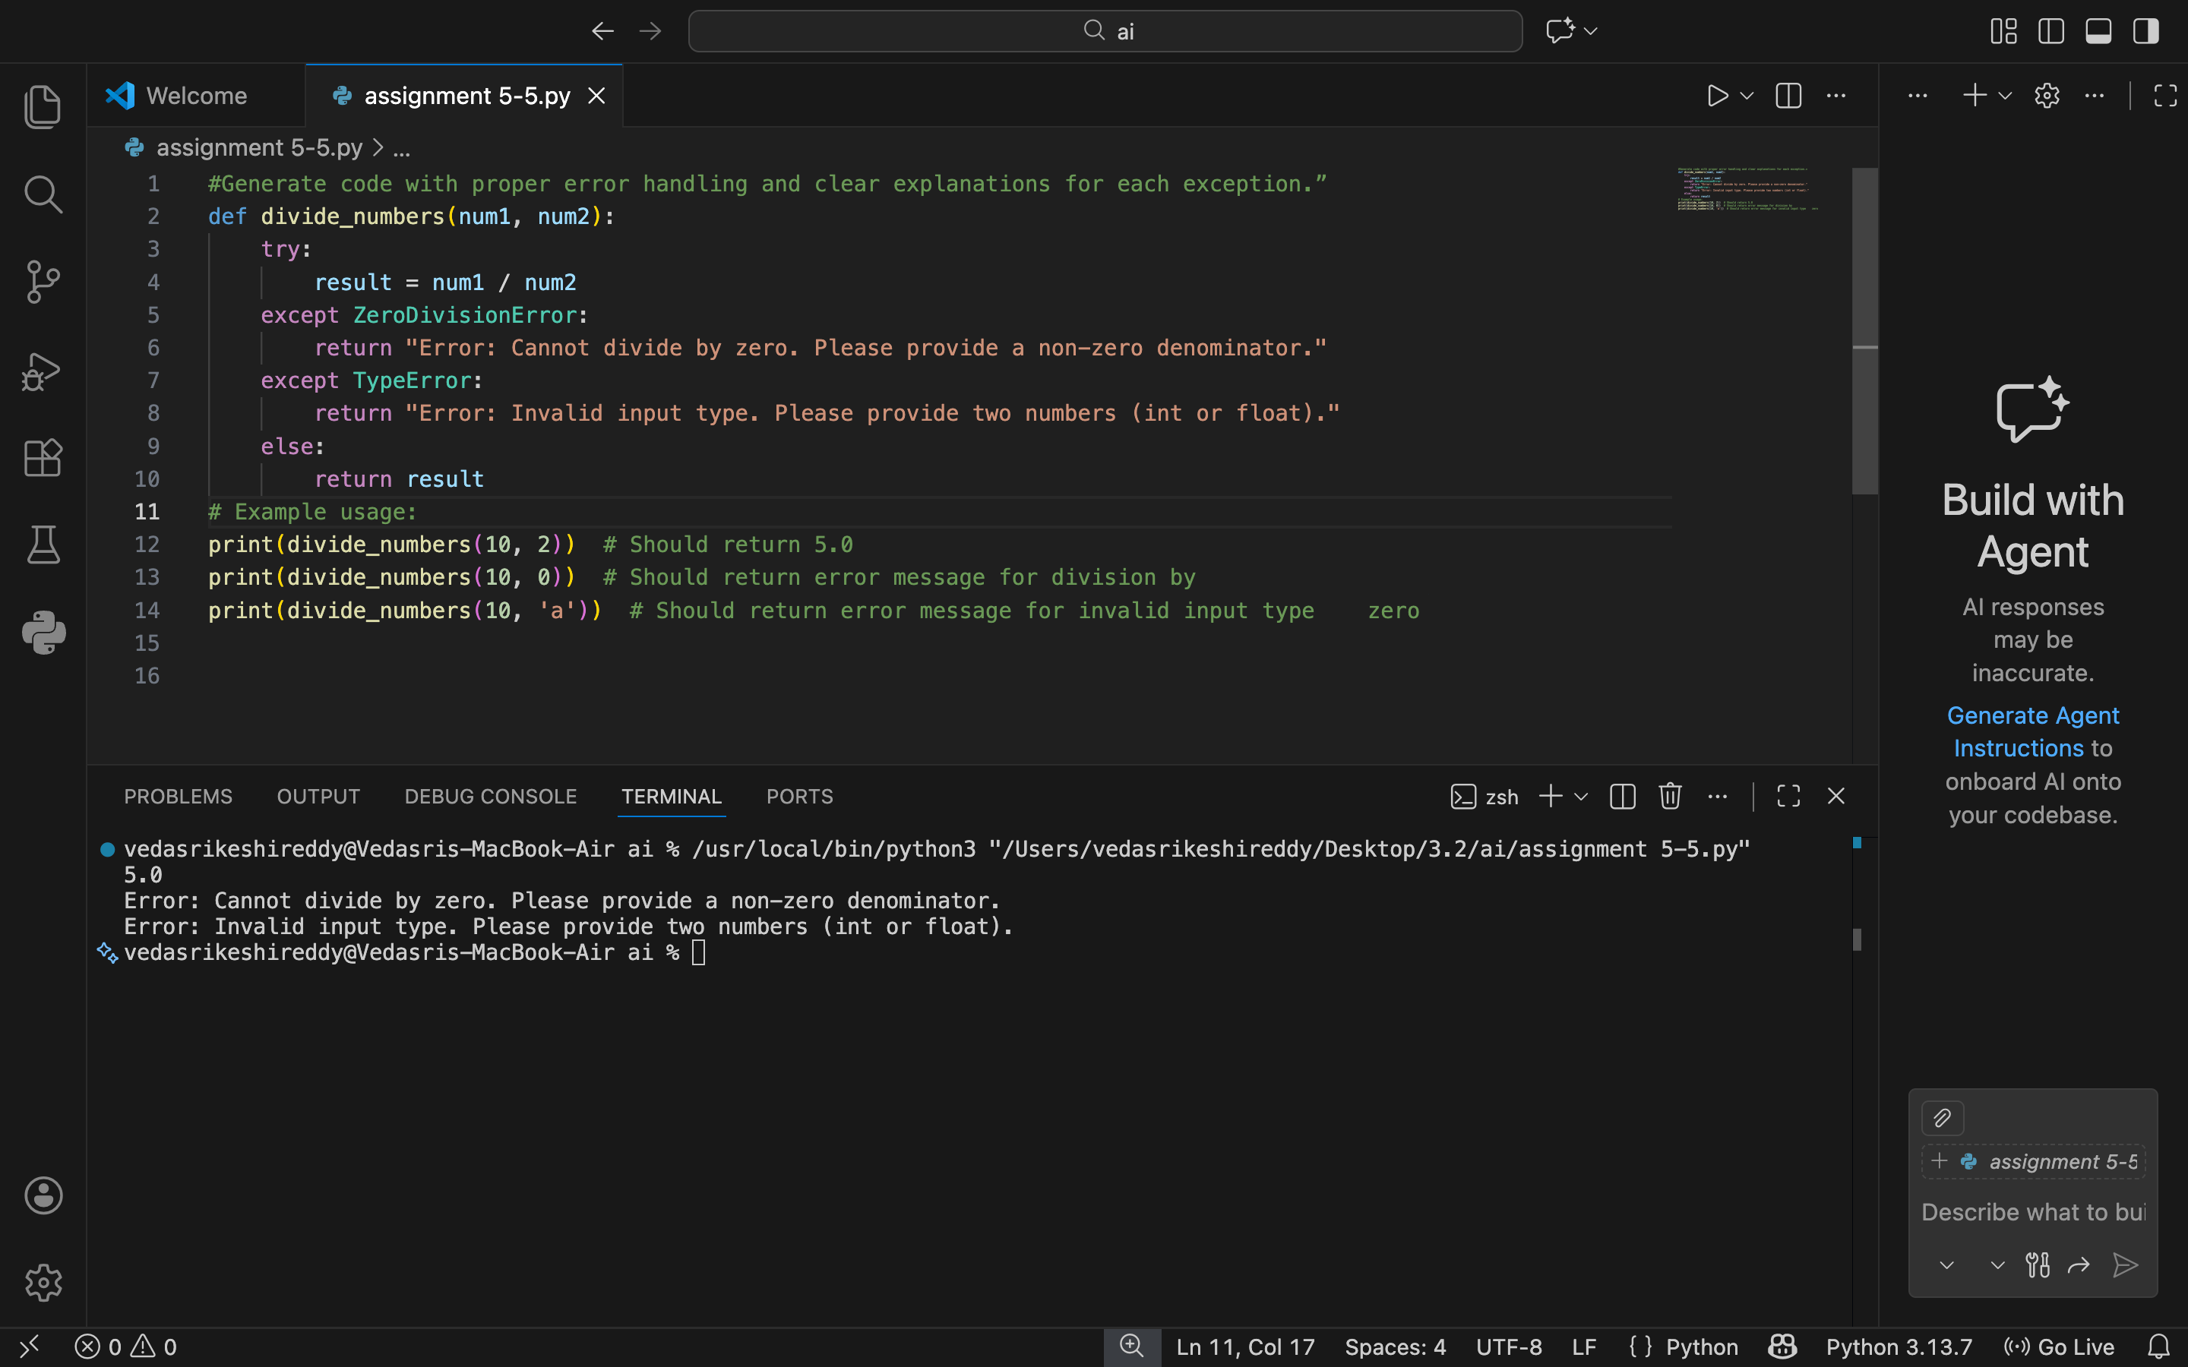

Justification:
The function `divide_numbers` attempts to divide two numbers while handling potential exceptions.
It uses a try-except block to catch specific exceptions:
ZeroDivisionError: Caught when attempting to divide by zero, providing a user-friendly message.
TypeError: Caught when the inputs are not numbers, ensuring type safety.
A general Exception catch to handle any other unexpected errors.
If no exceptions occur, the result of the division is returned.

Task 4
Use an AI tool to generate a Python-based login system.
Analyze: Check whether the AI uses secure password handling
practices.
Expected Output:
• Identification of security flaws (plain-text passwords, weak
validation).
• Revised version using password hashing and input validation.
• Short note on best practices for secure authentication.

Prompt:
#generate a python based login system with secured password handling

Code:
import hashlib
import os
class User:
def __init__(self, username, password):
self.username = username
self.salt = os.urandom(32) # A new salt for this user
self.password_hash = self.hash_password(password)

def hash_password(self, password):
"""Hash a password for storing."""
return hashlib.pbkdf2_hmac('sha256', password.encode('utf-8'), self.salt, 100000)

def verify_password(self, password):
"""Verify a stored password against one provided by user"""
return self.password_hash == hashlib.pbkdf2_hmac('sha256', password.encode('utf-8'), self.salt, 100000)
class LoginSystem:
def __init__(self):
self.users = {}

def register_user(self, username, password):
if username in self.users:
return "Error: Username already exists."
self.users[username] = User(username, password)
return "User registered successfully."

def login_user(self, username, password):
user = self.users.get(username)
if not user:
return "Error: Username does not exist."
if user.verify_password(password):
return "Login successful."
else:
return "Error: Incorrect password."
# Example usage:
login_system = LoginSystem()
print(login_system.register_user("user1", "securepassword")) # Should register successfully
print(login_system.login_user("user1", "securepassword")) # Should login successfully
print(login_system.login_user("user1", "wrongpassword")) # Should return incorrect password

Output:
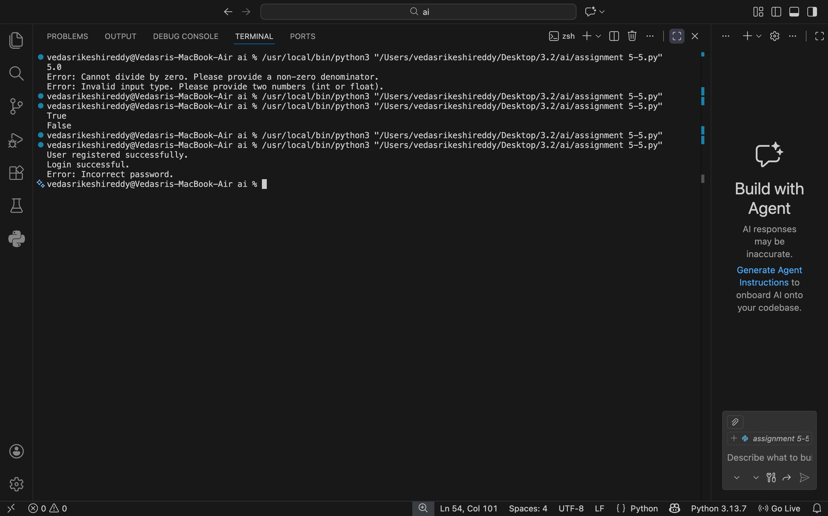

Justification:
# The code implements a simple login system with secure password handling using hashing.
# The `hash_password` function takes a plain text password and returns its SHA-256 hash.
# This ensures that the actual password is not stored in plain text, enhancing security.
# The `verify_password` function checks if a provided password matches the stored hashed password by hashing the provided password and comparing it to the stored hash.
# During login, the user provides a password, which is verified against the stored hash.

Task 5

Prompt:
#generate a python script that logs users activities with username,IP address timestamps to a log file.Examine

Code:
import logging
def setup_logging():
"""
Sets up the logging configuration to log user activities.
"""
logging.basicConfig(
filename='user_activity.log',
level=logging.INFO,
format='%(asctime)s - %(username)s - %(ip_address)s - %(message)s',
datefmt='%Y-%m-%d %H:%M:%S'
)
def log_user_activity(username, ip_address, activity):
"""
Logs a user's activity with username, IP address, and timestamp.
Parameters:
username (str): The username of the user.
ip_address (str): The IP address of the user.
activity (str): The activity performed by the user.
"""
logging.info(activity, extra={'username': username, 'ip_address': ip_address})

# Example Usage
if __name__ == "__main__":
# Setup logging first
setup_logging()

# Log multiple user activities
log_user_activity("john_doe", "192.168.1.10", "Logged in")
log_user_activity("john_doe", "192.168.1.10", "Viewed dashboard")
log_user_activity("john_doe", "192.168.1.10", "Logged out")

log_user_activity("vedasri", "10.0.0.5", "Uploaded assignment file")
print("User activities have been logged.")

Output:
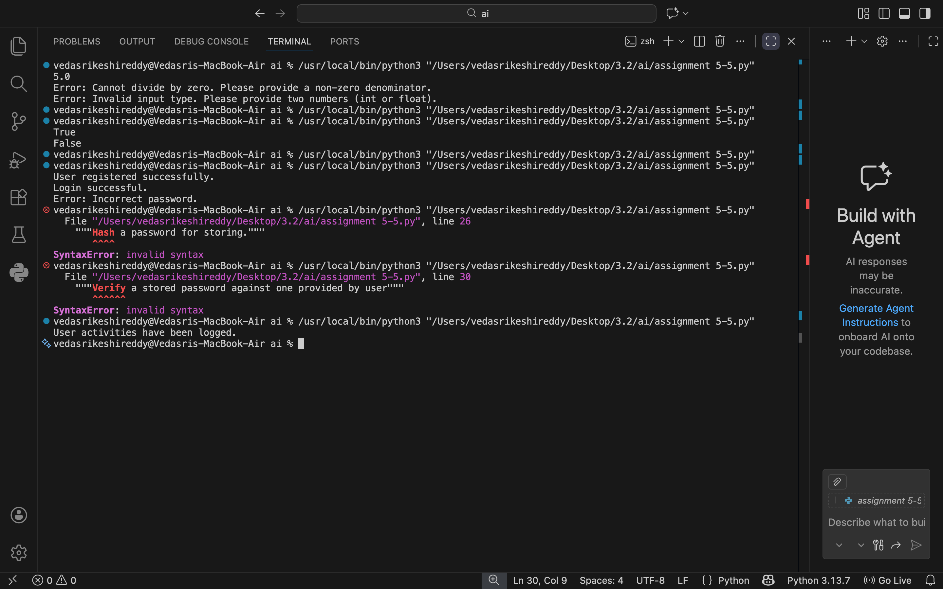

Justification:
# Examination of sensitive data logging:
# The script logs the username and IP address, which are considered sensitive information.
# To enhance security, consider anonymizing IP addresses or using hashed usernames.
# Additionally, ensure that the log file is stored securely with appropriate access controls to prevent unauthorized access
# to sensitive user activity data.

